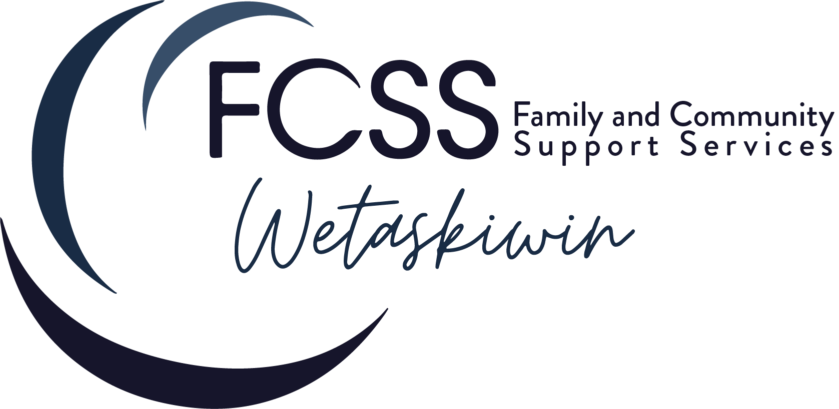

**Board Meeting - Feb. 1, 2023**

**FCSS Office in Wetaskiwin**

**In Attendance:** Cheryl Friesen, Gail, Hansen, Dean Billingsley, Wayne Neilsen, Wendy Hoyle, David Anderson, Carley Dolan, Paul Edginton

**Regrets:** Jamie Park

1. Wendy Hoyle calls meeting to order at 5:32pm

4. Wayne Neilsen moves to approve minutes from the January 4, 2023 meeting. Motion seconded by Dean Billingsley. Motion Approved.

5. Dean Billingsley adds item 8e to the agenda called board of directors changes. Wayne moves to approve the amended agenda. Dean Billingsley seconds the motion. Motion Approved.

6. Business arising from the Directors Report -

a)Question regarding domestic violence prevalence in the community and if there are sufficient resources to address the issue. Carley spoke about the director of Changing Ways from Camrose coming to meet with our team to discuss programs offered in Camrose to address violence. The DART team being dissolved and lack of funding was discussed. Board was curious what data is available to demonstrate the impact of domestic violence in Wetaskiwin. Carley is to investigate possible grants and /or partnerships to address domestic violence and gather data that is available.

b) Carley discussed RPACT team from RCMP assisting with a client that had appearingly severe mental health issues. They are engaged with the client now and have referred them to us for navigation services. We also discussed referral pathways to them and are able to refer clients directly to them that we feel need immediate assistance for mental health concerns.

c) Question posed regarding CAKE project and measurable outcomes. Discussion was had on what are the ways to measure success of the program. Engagement on social media has not been as robust as we had hoped and we are unsure of other measurable ways to evaluate this particular program. Some suggestions were made to create an option on the website to leave anonymous feedback and to pursue expanding our social media presence to other platforms. The board members got to deliver the CAKE items in January and most came back with positive feedback about the experience and getting to randomly surprise people with something positive. Discussion was had around knowing that both the CAKEees and the CAKEers do experience a positive outcome, although small when engaging with this program and that it is worthwhile whether it is measured or not. It was also discussed that for the small investment of time and money, this program reaches a very large number of people in the community and will assist in building more empathy and kindness into the local culture.

d) A request was made to put a hitch lock on the trailer.

e) A discussion was had regarding community engagement and BBQ’s and if we are duplicating services offered by Connect Wetaskiwin. Connect Wetaskiwin is engaging in asset mapping in Wetaskiwin and hope to engage the community through BBQ’s in the summer season. We plan to utilize our block party set up to host community BBQ’s to build connections in neighborhoods and allow people to meet their neighbors and establish better natural support networks. There is a possibility to partner with Connect on these community events, but awareness of whether people will feel inundated with questions that could negatively impact the ability to build a trusting relationship within the community for our agency was expressed.

f) A discussion was had regarding notice being sent to the Heritage Museum regarding the community grant request for 2022 and the board’s decision to not grant the money due to the reporting from the 2021 grant not being submitted. An email was sent to the Board Chair (according to the website) and the Executive Director on Jan 10/23. We have not received a response from them.

g) A discussion around Community Grants centered on whether copies of receipts for items purchased with grant funds should be required to be submitted back to us.

h) Dean Billingsley motioned “to change 2023 grant applications to include that copies of receipts will be required to be submitted with the final reporting.” Motion was seconded by Wayne Neilson. Vote was 4/4 in favor - motion carried.

i) Questions were brought up about holding the financial information pertaining to the grants and how it would be stored. Board decided that there would be a receipt verification sign off added to the final reporting for our staff to confirm that receipts were submitted and match the grant parameters. The copies of receipts would then be shredded and not stored on site.

7. Old Business

a) Moving away from the city was discussed. Paul explained that the GANTT chart detailing the process and timeline to have FCSS removed from City processes is almost complete and compliant with the proposed timeline. LAPP was notified that the FCSS employees would no longer be participating in the program. 2 of the current employees were hired as city employees and would receive ROE’s for the end of 2022. Accounts receivable and accounts payable have received the last items for 2022 and FCSS will be handling their own accounts payable and accounts receivable in 2023. FCSS employees have been removed from city IT systems. FCSS is still communicating with the city in regards to the status of retention of funds for the Mental Health and Addictions grant. We are waiting to hear back from the Government of Alberta if the request to retain funds and the proposed spending plan is approved. Paul will find out what reporting to city council is required from FCSS moving forward. Information regarding the change in contact for the charity status was sent to Carley to deal with. The GANTT chart is 95% complete. MOU and bylaws with the City need to be addressed. Paul plans to bring draft versions of MOU and bylaws to the next meeting.

b) A question was raised regarding new board members and if there is a requirement for city council to approve them. This was put off for the current meeting to be revisited at the next meeting with the drafts of the revised bylaws and MOU.

Board of directors has 2 new members: Gail Hansen and Kat McCallum.

Request to have advertisements for new board members go on social media once per month ongoing.

c) Update on the charity status will be provided at the next board meeting.

The 8/44 rule in the policy and procedure manual was raised as a concern. The current staff agreements say that their workday is 7.5 hours, not 8 hours. Policy manual will be amended to state that ‘time in lieu will be provided at a rate of 1.5 for overtime or statutory holidays worked.’ and ‘any hours over 7.5 daily and 37.5 weekly are considered overtime hours.’

8. New Business

a) GST rebate and where to deposit the funds from the rebate was brought up. A discussion was had around a reserve fund that could be used for GST rebates and any donations or fundraising dollars to be deposited into. This allows it to be separate from the grant funding that has specific parameters and mandate that must be adhered to. Board members are going to look into the Lacombe reserve fund policies and revisit the discussion at the next board meeting.

b) Gail is going to look through Lacombe’s FOIP policy and report back on what is included and how we can create our FOIP policy.

Craig’s FOIP requests are being left as is for the time being as his last communication with Carley was “Thank You” and did not answer the question regarding what specific information he was looking for to try and avoid the need to involve the lawyer to redact documents.

c) A question was raised regarding the current bylaws and if there was a copy of them that was complete. The copy found was missing a couple of pages. It appears that the bylaws are filed under the corporate registry with the date January 14, 2021. We will try to find a complete copy to bring to the next meeting for reference when reviewing the new draft.

e) Dean Billingsley added an item to the agenda regarding board changes. Dean asked to take a 6 month leave of absence from the FCSS board of directors starting July 1, 2023. Wayne Neilsen made a motion to “approve Dean’s 6 month leave of absence starting July 1, 2023. This leave is to be revisited in December 2023” Gail Hansen seconded the motion. 4/4 voted in favor - motion was carried.

d) Managing Director review was discussed in camera

Dean Billingsley made a motion to “initiate compensation as discussed in camera.” Wayne Neilsen seconded the motion. 4/4 voted in favor - motion passed.

9. Meeting adjourned at 8:26pm

Next meeting is March 7, 2023 @ 5:30pm